Gerstein lab experience in cancer genomics
The Gerstein lab has extensive experience with analyzing cancer genomes through our involvement in a number of cancer-focused consortia, including TCGA and PCAWG. In TCGA, we were involved in studies of prostate (Cancer Genome Atlas Research Network, 2015 ; Cancer Genome Atlas Research Network, 2016 ; Augspach et al, 2021) and kidney (Li et al, 2017) cancers, and some of this work involved detailed analyses into minor splicing in cancer contexts. The Gerstein has built software tools and developed computational methods for finding sites splice sites throughout the human genome. We have also co-lead a PCAWG sub-group to investigate the impact of non-coding mutations in cancer. We have continued to expand upon our widely-used Function-based Prioritization of Sequence Variants (FunSeq) tool to study somatic cancer variants (Khurana et al, 2013). We also developed FusionSeq (Sboner et al, 2010), which is a computational framework to identify fusion transcripts from paired-end RNA-sequence data. FusionSeq includes filters to remove spurious candidate fusions with artifacts such as misalignments or random pairings of transcript fragments, and it provides rankings for identified candidates. We also explored the properties and consequences of recurrent repeat expansions (rREs) spanning 29 cancer types (Erwin et al, 2022). We emphasize that many of these previous studies were carried out as part of joint efforts with the other groups, so our experience in these efforts is scientific and collaborative in nature.

Gerstein lab experience in minor splicing analysis
The Gerstein lab has worked closely with the research groups led by Drs. Mark Rubin and Rahul Kanadia to study systematic differences in gene expression associated with minor-intron-containing genes (MIGs). This work was published in Molecular Cell. In the context of this study, we used silhouette scores to rigorously demonstrate that MIGs exhibit stronger differential gene expression across cancer types and stages of cancer development, relative to genes that do not contain minor introns (that is, relative to non-MIG genes).

Gerstein lab experience in predicting disordered proteins and misfolding in proteins
Protein phase transitions (PPTs), especially those observed as a result of disordered states and aggregation, have the potential to interfere with protein-ligand binding by altering target structures, reduce functional availability, and affect binding thermodynamics and kinetics. In our recent work (Frank et al, 2024) we leveraged LLMs by fine-tuning the pre-trained ESM-2 model to predict PPTs and aggregation. Specifically, we demonstrated that the LLM embedding vectors can differentiate between sequences with high aggregation propensity from those with low aggregation propensity (Fig. 1).
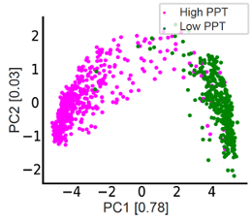
Fig. 1. PCA of the embedding vectors, extracted from the LLM, and the biophysical features for both classification tasks.
Preliminary results using GNNs to predict IDRs: We also developed a method that is designed to determine whether a specific subregion within a protein adopts disordered states (even if the entire protein itself does not adopt a disordered state) (Wang et al, 2024). Specifically, we introduced the GP-GNN framework, a GNN-based approach designed for predictive tasks where initially unknown subsystems may be crucial for information extraction. Our framework dynamically learns advantageous graph structures, hence, enabling improved graph representation learning. Specifically, we formulated a similarity measure that captures the probability of node pairs jointly exhibiting characteristic patterns within larger systems and used this measure to group nodes into clusters. Connections between clusters are considered unlikely to be relevant to the task and are removed, generating multiple subgraphs before graph representation learning via message passing. This is to confine information sharing within subgraphs during the initial network layers. We leveraged a linear layer to extract meta-features, allowing the similarity measure to be trained with task labels, thereby facilitating task-specific adjustments in the model’s predictions. In the final network layers, the framework captures interactions between the subgraphs. We demonstrated the effectiveness of GP-GNN for predicting protein liquid-liquid phase separation (LLPS), where the input consists of molecular protein graphs, and the output indicates whether the protein undergoes LLPS. Since LLPS is primarily driven by domains such as IDRs, GP-GNN identifies these critical domains as subgraphs. Our model achieved state-of-the-art performance in predicting LLPS proteins, including regulators and scaffolds, using both PDB and AlphaFold-generated graph structures. Additionally, in related work, we showed that a similar approach accurately identified tumor and microenvironment regions that align closely with pathologist annotations (Song et al, 2024).
Gerstein lab experience in studying protein dynamics
We developed STRESS, a tool to identify allosteric residues from protein structures (Clarke et al, 2016). STRESS employs coarse-grained models of protein dynamics and conformational changes in order to predict surface pockets that may strongly influence dynamics if occluded by ligands (Fig. 2). We have used this tool to highlight examples of allosteric residues that help explain disease-associated variants. Using the same dynamic model generation scheme applied by STRESS, we also developed ​​HotCommics, a framework to identify cancer driver genes using a dynamics-based search of mutational hotspot communities within structures (Kumar et al, 2019). Relative to existing cancer hotspot detection methods using structural data, we applied ​​HotCommics to demonstrate how protein dynamics significantly increases the sensitivity for detecting disease-associated gene.
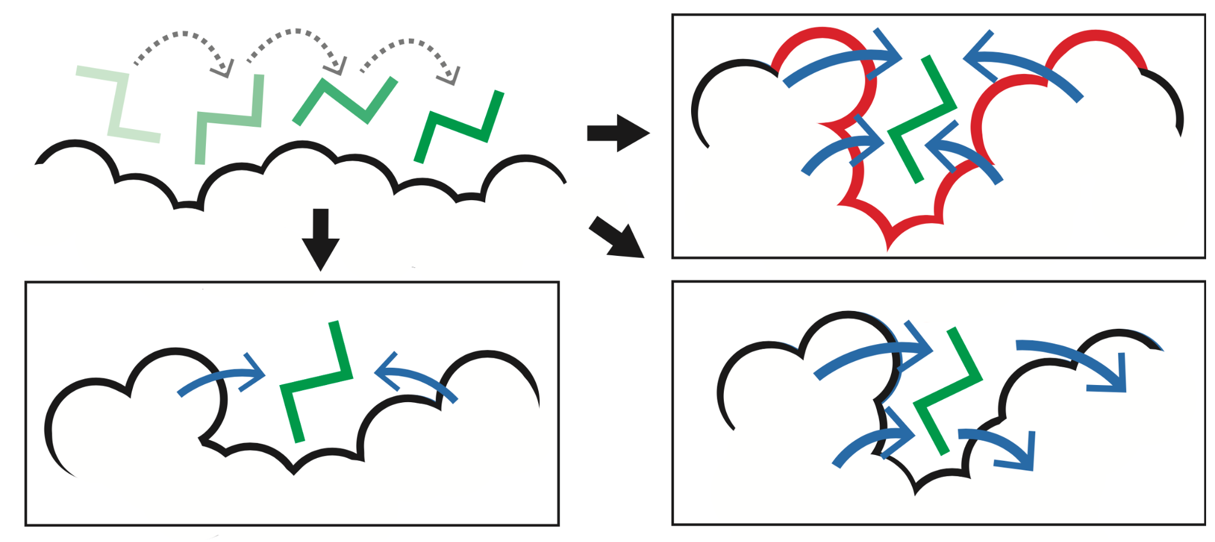
Fig 2. STRESS. Identifying key surface pockets using Monte Carlo simulations. This approach is designed to identify candidate sites wherein ligand occlusion may drastically affect conformational changes and dynamics (top-right).

Gerstein lab experience in studying sequence variation
Preliminary results on studying genomic sequence variation: We developed multiple computational tools and analysis pipelines to study genomic sequence variation and the associated downstream effects of variants. VAT (Variant annotation tool) annotates protein sequence changes resulting from genetic mutations, categorizing mutations as synonymous, missense, nonsense, or splice-site disrupting (Habegger et al, 2012). We also developed ALoFT (Annotation of Loss-of-Function Transcripts) predicts the disease-causing potential of loss-of-function (LoF) events, distinguishing between deleterious heterozygous and homozygous mutations, and it has been used to analyze somatic variants in cancer exomes (Balasubramanian et al, 2017). We applied the concept of localized protein frustration to evaluate the structural impact of variants by calculating changes in localized physical metrics to assess how genetic variants affect protein structure and stability (Fig. 3) (Kumar et al, 2016). This has been used to differentiate gain- and loss-of-function variants in oncogenes and tumor suppressors.
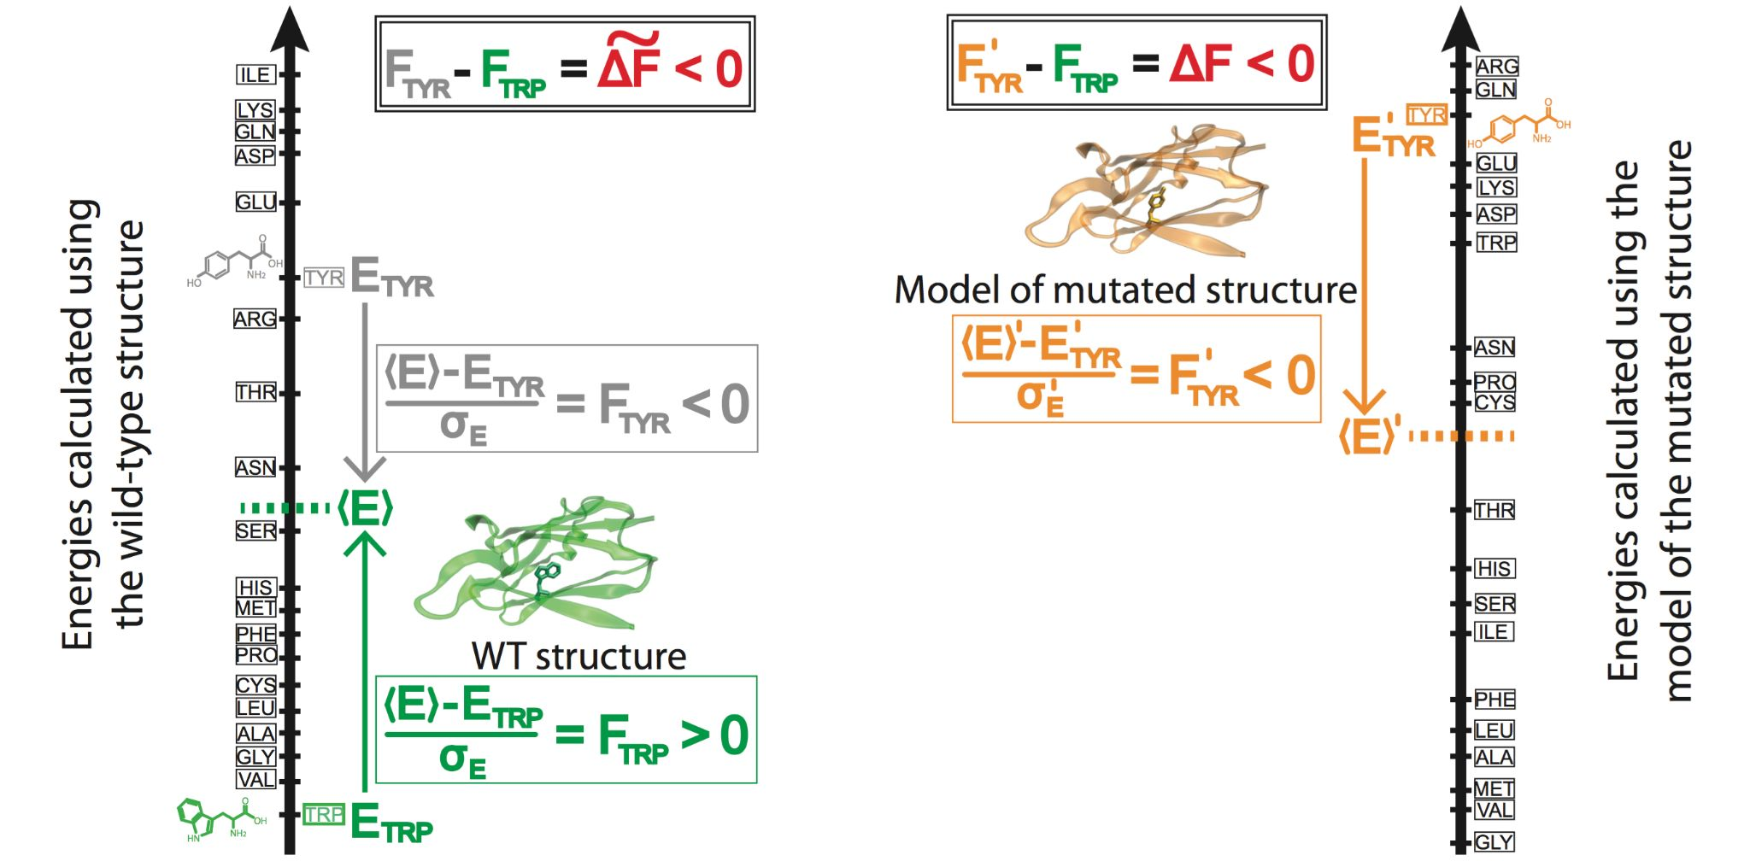
Fig. 3. Prioritizing the effect of SNVs based on changes in localized perturbations (as measured by frustration).
We also have extensive experience with conducting analyses related to allele-specific expression (ASE). In particular, we developed AlleleSeq, a computational pipeline that was originally used for identifying and quantifying ASE in GM12878 (Rozowsky et al, 2011). We have applied AlleleSeq to a broad spectrum of personal and functional genomics data. We annotated variants associated with ASE in a large pool of individuals from the 1000 Genomes Project. The results were made available as an online resource, AlleleDB (http://alleledb.gersteinlab.org) (Chen et al, 2016).
References
Augspach, Anke, et al. "Minor intron splicing is critical for survival of lethal prostate cancer." Molecular cell 83.12 (2023): 1983-2002.

Balasubramanian, S. et al. Using ALoFT to determine the impact of putative loss-of-function variants in protein-coding genes. Nature communications 8, 382, doi:10.1038/s41467-017-00443-5 (2017).

Cancer Genome Atlas Research N. The Molecular Taxonomy of Primary Prostate Cancer. Cell. 2015;163(4):1011-25. Epub 2015/11/07. doi: 10.1016/j.cell.2015.10.025. PubMed PMID: 26544944; PMCID: PMC4695400.

Cancer Genome Atlas Research Network. "Comprehensive molecular characterization of papillary renal-cell carcinoma." New England Journal of Medicine 374, no. 2 (2016): 135-145.

Chen, J. et al. A uniform survey of allele-specific binding and expression over 1000-Genomes-Project individuals. Nature communications 7, 11101, doi:10.1038/ncomms11101 (2016).

Clarke, D. et al. Identifying Allosteric Hotspots with Dynamics: Application to Inter- and Intra-species Conservation. Structure (London, England : 1993) 24, 826-837, doi:10.1016/j.str.2016.03.008 (2016).

Erwin, Graham S., Gamze Gürsoy, Rashid Al-Abri, Ashwini Suriyaprakash, Egor Dolzhenko, Kevin Zhu, Christian R. Hoerner et al. "Recurrent repeat expansions in human cancer genomes." Nature (2022): 1-7.

Frank, M., Ni, P., Jensen, M. & Gerstein, M. B. Leveraging a large language model to predict protein phase transition: A physical, multiscale, and interpretable approach. Proceedings of the National Academy of Sciences of the United States of America 121, e2320510121, doi:10.1073/pnas.2320510121 (2024).

Khurana, Ekta, Yao Fu, Vincenza Colonna, Xinmeng Jasmine Mu, Hyun Min Kang, Tuuli Lappalainen, Andrea Sboner et al. "Integrative annotation of variants from 1092 humans: application to cancer genomics." Science 342, no. 6154 (2013): 1235587.

Kumar, S., Clarke, D. & Gerstein, M. Localized structural frustration for evaluating the impact of sequence variants. Nucleic acids research 44, 10062-10073, doi:10.1093/nar/gkw927 (2016).

Kumar, S., Clarke, D. & Gerstein, M. B. Leveraging protein dynamics to identify cancer mutational hotspots using 3D structures. Proceedings of the National Academy of Sciences of the United States of America 116, 18962-18970, doi:10.1073/pnas.1901156116 (2019).

Habegger, L. et al. VAT: a computational framework to functionally annotate variants in personal genomes within a cloud-computing environment. Bioinformatics 28, 2267-2269, doi:10.1093/bioinformatics/bts368 (2012).

Li S, Shuch BM, Gerstein MB. Whole-genome analysis of papillary kidney cancer finds significant noncoding alterations. PLoS genetics. 2017;13(3):e1006685. Epub 2017/03/31. doi: 10.1371/journal.pgen.1006685. PubMed PMID: 28358873; PMCID: PMC5391127.

Rozowsky, J. et al. AlleleSeq: analysis of allele-specific expression and binding in a network framework. Molecular systems biology 7, 522, doi:10.1038/msb.2011.54 (2011).

Sboner, Andrea, Lukas Habegger, Dorothee Pflueger, Stephane Terry, David Z. Chen, Joel S. Rozowsky, Ashutosh K. Tewari et al. "FusionSeq: a modular framework for finding gene fusions by analyzing paired-end RNA-sequencing data." Genome biology 11 (2010): 1-19.

Song, T. et al. Predicting spatially resolved gene expression via tissue morphology using adaptive spatial GNNs. Bioinformatics 40, ii111-ii119, doi:10.1093/bioinformatics/btae383 (2024).

Wang, G., Warrell, J., Zheng, S. & Gerstein, M. A variational graph-partitioning approach to modeling protein liquid-liquid phase separation. Cell Reports Physical Science 5, doi:10.1016/j.xcrp.2024.102292 (2024).

