1. Explain why the Perceptron can't solve the XOR problem. (10pts)

The positive and negative cases cannot be separated by a plane

2. Explain what’s the gradient vanishing problem in deep neural networks and why ReLU activation function solves the problem. (10pts)

If gradient <1, after multiple times of multiplication it is close to 0.
Gradient is either 1 or 0.

3. Derive the gradient of a Softmax activation function output yi with respect to its logit zi. (10pts)
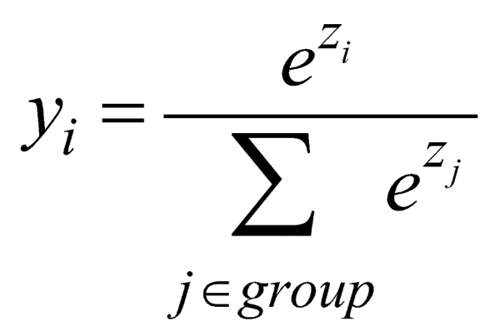

Answer: 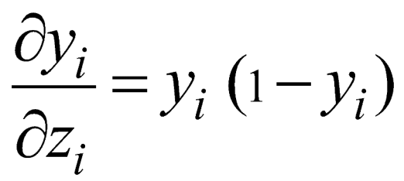

4. What are the benefits of variational autoencoder (VAE) over deterministic autoencoder? (10pts)

Produce new content

5. Describe both axes in terms of TP, TN, FP, FN when plotting the ROC curve. (10pts)
False Positive Rate (FPR) = FP / (FP+TN)
True Positive Rate (TPR) = TP / (TP+FN)

6. Describe the meaning of each letter in the following equation of calculating network modularity. (10pts)
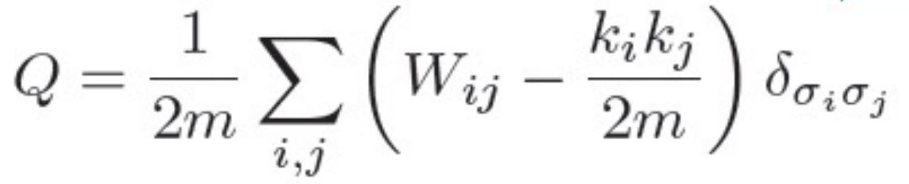
m: number of edges
W: adjacency matrix
k_i: degree of node i
delta: whether or not i and j are in the same module/cluster/community
sigma_i: community/cluster label of node i

7. Describe the two steps for generating a scale-free network. (10pts)
• GROWTH: starting with a small number of vertices m0 at every timestep add a few new vertices
• PREFERENTIAL ATTACHMENT: the probability Π that a new vertex will be connected to vertex i depends on the connectivity of that vertex

8. Below, a Ramachandran plot based on the original theoretical calculations is shown. Describe the four regions in the plot that correspond to α-helix and β-sheet backbone conformations and describe roughly what is the difference between the yellow and red regions of the plot. (10pts)

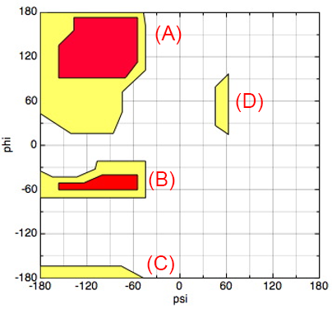
Answer: Top left/bottom left region are beta sheets, region at left at phi = -60° is a right-handed alpha helix, small region at psi = 60° and phi = 60° is left-handed alpha helix.

Red regions are the “normally allowed” region, where standard (i.e. strict) contact distances between hard sphere atoms are assumed, and the yellow regions are the “outer” regions, where shorter (i.e. lenient) contact distances between hard sphere atoms are assumed.

9.
(A) Suppose an unbranched, simple polymer has N monomers in three spatial dimensions. How many dihedral angles does it have? How many bond angles (between three adjacent monomers) does it have? (4pts)

N-3 dihedral angles. N-2 bond angles.

(B) Name three highly hydrophobic amino acids. (6pts)

ILE, LEU, PHE, VAL, TRP, MET, CYS, ALA

10. Name two common features of intrinsically disordered proteins. (10pts)

Answer: No well-defined tertiary structure/dynamic conformational changes, can liquid-liquid phase separate/aggregate, tend to be mostly composed of charged amino acids

[Bonus] What is the densest packing fraction for disordered collections of ellipsoids in three spatial dimensions? What is the packing fraction of all-atom hard-sphere (i.e. explicit hydrogen) representations of residues in protein cores? (10pts)

Φ = 0.71-0.73
Φ = ~0.56

