1. (10 pts) Name three types of terms in typical potential energy functions for proteins.

2. (10 pts) What is the densest packing fraction for disordered collections of monodisperse hard spheres? What is the packing fraction of all-atom hard-sphere (i.e. explicit hydrogen) representations of residues in protein cores?

3. (10 pts) Plot the purely repulsive linear spring potential (V/ε versus rij/σij) given by

for rij ≥ σij and V(rij) = 0 for rij < σij, where rij is the center-to-center separation between atoms, σij = (σi+σj)/2 is the average diameter of spherical atoms i and j, and the strength of the potential ε is a constant.

4. (10 pts) Calculate the x-, y-, and z-components of the force on atom i from neighboring atom j, ${\vec{F}}_{ij}=-\frac{dV}{dr_{ij}}{\hat{r}}_{ij}$ from the purely repulsive linear spring potential in question #3.

5. (10 pts) What is the difference between a deterministic and stochastic model? Which term applies to Ordinary Differential Equation (ODE) models?

6. (10 pts) What does it mean for a model parameter to be identifiable?

7. (10 pts) Below, a Ramachandran plot based on the original theoretical calculations is shown. Label the regions of the plot that correspond to α-helix and β-sheet backbone conformations and describe roughly what is the difference between the yellow and red regions of the plot.

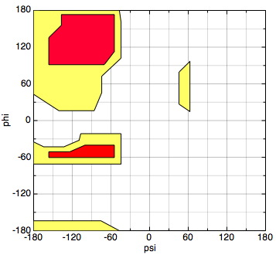

8. (10 pts) Name two common features of intrinsically disordered proteins.

9. (10 pts) In the context of mathematical modeling, what is an F test used for? What does it mean when F >> 1?

10. (10 pts) The SIR model can be used to predict the course of an epidemic in a large population. In the model equations given below, describe the meaning of each state variable (S, I and R) and each parameter ( and ):



11. (10 pts) How does the radius of gyration Rg ~ Nν grow the number of residues N for a protein that behaves as a a) a fully extended chain, b) random walk, and c) self-avoiding random walk?