1. Database

a. [5 pts] In relational databases, what is the difference between a primary key and a foreign key?

Primary keys are unique to each table and aim to identify rows; a foreign key is a primary key of another table predominantly used to join tables

b. [5 pts] How can foreign keys be used to join tables?

A foreign key in one table is the primary key of another table; tables are joined by matching the values of the foreign key with the values in the table where the column is a primary key.

2. Genomics

a. [5 pts] In sequencing, what do we mean by “read coverage”?

Number of reads mapped to a region

b. [5 pts] What is the main advantage of Third-generation sequencing technologies (i.e., Nanopore-based or Pacific Bioscience)?

Longer read lengths

3. [10 pts] A sample mass spectrum is shown below. What do X-axis and Y-axis of the mass spectrum denote?

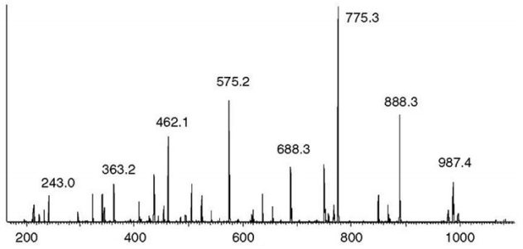

- X = m/z (mass-to-charge ratio)
- Y = Relative abundance or Intensity

4. [10 pts] Circle all methods to identify protein structures

A. X-ray crystallography
B. NMR
C. Mass Spectrometry
D. Cryo-EM
E. SILAC

A, B and D

5. [10 pts] What is the typical number of single nucleotide polymorphism (SNP) in one person’s typical genome with respect to the human reference genome?

A. ~4,000
B. ~40,000
C. ~400,000
D. ~4,000,000
E. ~40,000,000

D

6. [10 pts] Why are FASTA and BLAST preferred to dynamic programming approaches to searching sequence databases?

Acceptable answers are:
FASTA and BLAST are faster by utilizing a hash table
(reduces time complexity, search space)
Dynamic programming is impractical to use due to O(n^2) complexity

7. [20 pts] Align the following two sequences using the Needleman-Wunsch global alignment algorithm. Show the complete dynamic programming matrix, and circle one optimal traceback on the matrix.
Sequence 1: ACTGCA
Sequence 2: ACATGA

Use the following scoring scheme in the score matrix:
Match: +2
Mismatch: 0
Gap: 0

 | A | C | T | G | C | A
A
C
A
T
G
A

Answer (bottom up):
 | A | C | T | G | C | A
A | 10 | 6 | 4 | 4 | 2 | 2
C | 6 | 8 | 4 | 2 | 4 | 0
A | 8 | 6 | 4 | 2 | 2 | 2
T | 4 | 4 | 6 | 2 | 2 | 0
G | 2 | 2 | 2 | 4 | 2 | 0
A | 2 | 0 | 0 | 0 | 0 | 2

Alternatively (top down):
 | A | C | T | G | C | A
A | 2 | 0 | 0 | 0 | 0 | 2
C | 0 | 4 | 2 | 2 | 4 | 2
A | 2 | 2 | 4 | 4 | 4 | 6
T | 0 | 2 | 6 | 4 | 4 | 4
G | 0 | 2 | 4 | 8 | 6 | 6
A | 2 | 2 | 4 | 6 | 8 | 10

AC-TGCA
ACATG-A

8. [5 pts] Draw the two principal components (PC1, PC2) on the graph below.
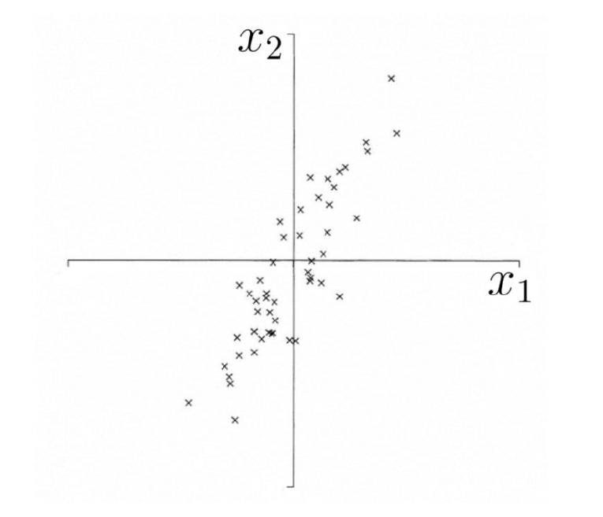

9. [5 pts] In SVD, the data matrix A is decomposed as A = USV’. Suppose A is a 3*18 matrix. What are the dimensions of U, S, V respectively?

U: 3 x 3
S: 3 x 18
V: 18 x 18

Also acceptable answer (based on lecture note):
U:3 x 18
S: 18 x 18
V: 18 x 18

10. Position Probability Matrix (PPM) is commonly used to represent motifs (patterns) in biological sequences.

a. [5 pts] Given the following DNA sequences, complete the corresponding position probability matrix profile.

DNA 1: GAGGTTGA
DNA 2: TCCGTTCA
DNA 3: CAGGTAGA
DNA 4: ACAGTTTA
DNA 5: TAGGTCAA

 | Pos 1 | Pos 2 | Pos 3 | Pos 4 | Pos 5 | Pos 6 | Pos 7 | Pos 8
A | 0.2 | 0.6 | 0.2 | 0 | 0 | 0.2 | 0.2 | 1
C | 0.2 | 0.4 | 0.2 | 0 | 0 | 0.2 | 0.2 | 0
G | 0.2 | 0 | 0.6 | 1 | 0 | 0 | 0.4 | 0
T | 0.4 | 0 | 0 | 0 | 1 | 0.6 | 0.2 | 0

b. [5 pts] Using the profile above, calculate the probability of the sequence S = GAGGTACA being observed.

0.00288
Or
288 * 10^-5
Or
0.288 %
Or
9/3125

